Requirement Analysis
Technology Stack (Architecture & Stack)
Date | 09 September 2026
Student Name | Jetti Harika
Project Name | Automated Network Request Management in ServiceNow
Maximum Marks

Technical Architecture
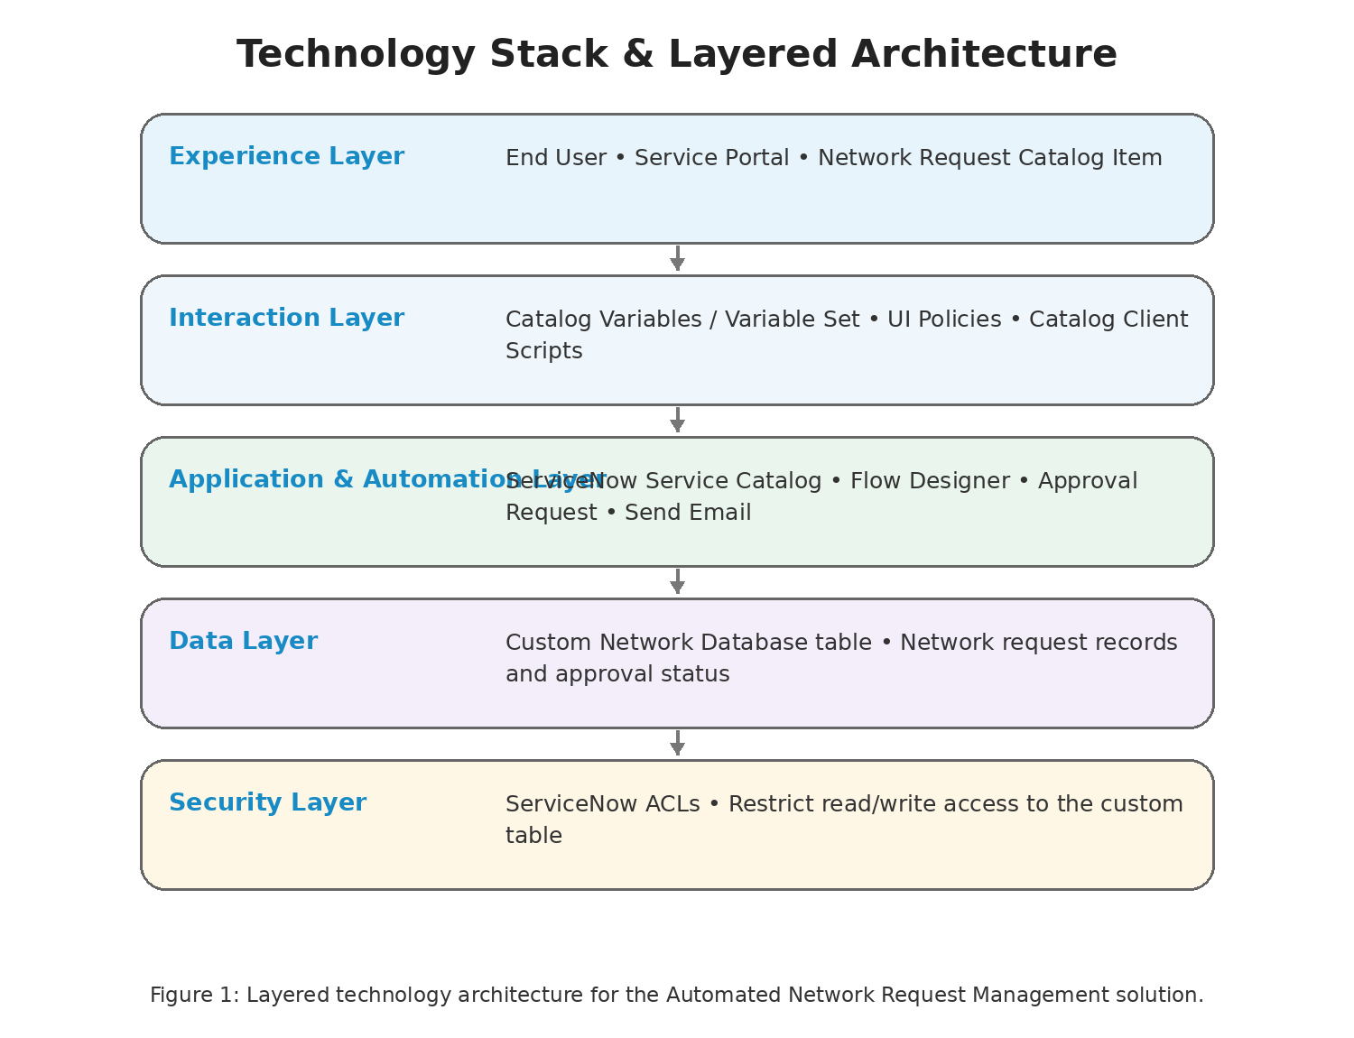

The solution is implemented within ServiceNow using the Service Portal, Service Catalog, catalog variables and variable sets, Flow Designer, a custom Network Database table, approval requests, UI Policies, catalog client scripts, and ACLs. No external API, machine-learning model, or separate cloud database is specified in the supplied project instructions.
Figure 1: ServiceNow technology stack and request-management architecture flow.

Table-1: Components & Technologies
S.No | Component | Description | Technology
1 | User Interface | Service Portal through which end users search for Network Requests, fill required details, and submit requests. | ServiceNow Service Portal
2 | Application Logic-1 | Catalog request handling and variable configuration. | ServiceNow Service Catalog
3 | Application Logic-2 | End-to-end request lifecycle automation including Get Catalog Variables, Create Record, Send Email, Ask for Approval, If/Else, and Update Record. | ServiceNow Flow Designer
4 | Application Logic-3 | Dynamic field visibility and dependent form behaviour. | Catalog UI Policies and Catalog Client Scripts
5 | Database | Stores network request records and fields including Database Number, Assignment To, Mobile Number, Total Amount, Mode of Payment, Type of Connection, Customer Address, Approval Status, and Requested For. | ServiceNow custom Network Database table
6 | Approval | Stores/displays approval request information related to the Network Database record. | ServiceNow Approval Request / sysapprovals relationship
7 | Email Notification | Communicates request progress from the automated flow. | ServiceNow Flow Designer Send Email action
8 | External API-1 | No external API is specified in the project instructions. | Not specified
9 | Machine Learning Model | No machine-learning model is specified in the project instructions. | Not specified
10 | Infrastructure (Server / Cloud) | Development and testing are performed in a ServiceNow Personal Developer Instance (PDI). | ServiceNow PDI

Table-2: Application Characteristics
S.No | Characteristics | Description | Technology
1 | Open-Source Frameworks | No external open-source framework is specified. | Not specified
2 | Security Implementations | Default ACLs on the custom table are used to restrict read/write access according to configured access controls. | ServiceNow ACLs
3 | Scalable Architecture | The solution uses a structured custom table and automated Flow Designer process; no specific microservices or scaling technology is specified. | ServiceNow platform
4 | Availability | The solution runs within the ServiceNow platform/PDI; no separate availability infrastructure is specified. | ServiceNow platform
5 | Performance | Project objectives include reduced manual effort and faster request fulfilment; no requests-per-second, caching, or CDN metric is specified. | ServiceNow Flow Designer / Service Portal

